# ITEC 4200 Advanced Database Semester Project

Student Name: Brian Torok

Semester: Fall 2018

Name of Project: Musical Equipment Store Chain

Email: btorok1@ggc.edu

Phone number: 404-547-6732

**EXECUTIVE SUMMARY**

**Objective**

This database will be designed for the purpose of keeping track of a music store’s interactions between customer, stores, its employees, and all items bought and sold by the chain.

**Goals**

The goal of this database is to provide a useful platform for a music store to keep track of its sales and interactions with customers by each of its sales associates. It would also provide the ability to query which employees have been the most successful, and what customers have provided them with the most business, and the ability to perform analysis on trends in sales.

**Solution**

The solution to reach the goal is to create a database with multiple tables and relationships regarding individual store locations, sales associates, customers, items sold, items in stock, and a customer-location table. Relationships regarding these tables and queries to analyze the data would also be included in the database. It will be built in Oracle 11g Express Database.

**Benefits to Users**

The database will provide a useful and simple tool for keeping track of the flow of business and provide a powerful tool for analyzing business data.

**Project Outline**

The project will contain the following major components:

* Schema Design
* Entity-Relationship Diagram
* Table Implementation
* Queries
* Reports

**Part II. Schema Design**

**STORE-LOCATION** (LocationID, StreetAddress, City, State, ZipCode)

**ITEMS** (ItemID, Price, ProfitMargin, ItemType)

**ITEM-LOCATION** (LocationID, ItemID, Inventory)

FK LocationID 🡪 LOCATION

FK ItemID 🡪 ITEM

**SALESASSOCIATE** (AssociateID, FirstName, LastName, StreetAddress, City, State, Zip, LocationID)

FK LocationID 🡪 STORE_LOCATION

**CUSTOMER** (CustomerID, PhoneNumber, Email, ZipCode)

**CUSTOMER-LOCATION** (CustomerID, StoreID)

FK CustomerID 🡪 CUSTOMER

FK StoreID 🡪 STORE_LOCATION

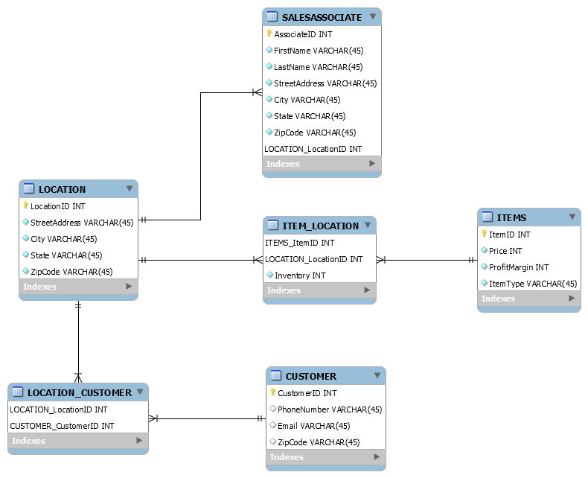

**Entity-Relationship Diagram**